TECHNICAL PROJECT REPORT

# Title of Invention / Project:

AUTOMATED HEADLIGHT CONTROL

# Team Members / Inventors:

|  |  |  |  |  |  |
| --- | --- | --- | --- | --- | --- |
| **S. No.** | **Name** | **Department** | **Designation** | **Mobile** | **E-Mail** |
| 1. | Shrey Nagpal | CSE-AI&ML | Student | 7905719228 | shreydancingboy@gmail.com |
| 2. | Yash Pant | CSE-AI&ML | Student | 6392411697 | pantyash74@gmail.com |
| 3. | Sahil Khan | CSE-AI&ML | Student | 8894166766 | sahil.k2164@gmail.com |
| 4. | Khushal Thakur | ECE | Mentor | 9646030764 | khushal.thakur@cumail.in |
| 5. | Anshul Sharma | ECE | Mentor | 9478697475 | anshulsharma.ece@cumail.in |
| 6. | Kiran Jot Singh | ECE | Mentor | 9463909689 | kiranjotsingh.ece@cumal.in |
| 7. | Divneet Singh Kapoor | ECE | Mentor | 9878422653 | divneet.ece@cumail.in |

Section – 1 (IPR Related)

# Brief Abstract (500 words):

* Problem your project is solving:

We are well aware that in day to day life, with human unnecessary negligence they often forget to do the obvious things. One such example is the case where most humans forget to switch off the headlights of their vehicles after use at night, which is evident from the glowing headlights in the morning and our fellow riders on the road often shout out of even petty general concern asking them to switch off their headlights. This problem often results in unnecessary battery wastage and thus making some losses for the consumers to purchase new battery frequently. Thus this project is somewhat an effort to solve this problem.

* How are you solving that (solution)?

We aim at solving this problem by the use of an LDR (i.e. Light Dependent Resistor). The main use of an LDR is to control the flow of current depending on the amount of light it receives. If the light is not adequate its resistance increases and it restricts the flow of current and otherwise it allows the current to pass. In the project we are using it as a device on which when the sunlight falls it restricts the flow of current not allowing it to reach the headlight so it does not glow and at night when no light reaches it allows the passing of current making the headlight to glow. The headlight here is represented by a 15 watt-12 volt bulb and the bike battery by an A.C source converted to D.C by an Adapter or a portable D.C battery of 12 volt. The power source passes the stabilised current to the LDR which controls the further flow of current depending on the amount of light received. There was an attempt to solve this problem by removing the switch but this made the situation worse for the headlights in these new upcoming vehicles always remained ON leading to an extensive loss of battery life. Thus this was a failed attempt to bring out an innovation in the current scenario. Our mechanism will help to save a lot of battery life which will be financially helpful to the consumer and also save him from the cumbersome work to remember ON and OFF the headlight again and again. This mechanism can find its application in various other situations like in the case of a street light/lamp where it can automatically turn the lamp ON at the evening or night time and OFF in the morning. This will shape the work of a person to daily go and switch them ON and OFF manually.

* Additional modifications that can cater to improved solution:

To further improve on the provided solution we can make an effort to make the product compact and cheaper. Also an even higher sensitivity LDR can be used which may make the intensity of the glow of headlights according to the weather conditions like at dusk the headlight may glow with some less intensity at night it may glow with a brighter intensity. This will not cause the brightness of the light at dusk to pinch in the eyes of the fellow riders and will be more user compatible. “In a bike the LDR will be placed near the key slot for its exact place for adequate amount of light to reach the LDR for the circuit to function.”

# Existing state-of-the-art and Drawbacks in existing state-of-the-art

|  |  |  |
| --- | --- | --- |
| **S. No.** | **Existing state of art** | **Drawbacks in existing state of art** |
| 1 | Old switch controlled headlights.  Patent Ref: US2686277A | Often left un-switched after use causing loss of battery.  Reference: Normal bikes on road |
| 2 | Some new vehicles came up with a solution in which headlight always remain on. | Extensive loss of battery.  Reference: A recently launched Activa 4G model |

# Novel/Additional modifications that you can propose to improve upon drawbacks

* Using a more feasible power supply.
* Using a higher sensitivity which may allow the measured current to flow.

# Advantages

* Less power consumption.
* The brightness of the headlight would vary with the intensity of sun light.

## A similar patent ref for the project: US4236099A

# Block Diagram

(*Functional diagram depicting the flow of information in your system. Do not define exact components, only use generic terms. Must include modifications as well.)*

RELAY

MODULE

LDR

BATTERY

BULB

12V

BATTERY

BATTERY

Section – 2 (Real Project)

# Materials Quantity

* 12 volt battery X 1
* 15W-12V Bulb X 1
* Bulb holder X 1
* Relay module X 1
* LDR X 1
* 47k ohm resistor X 1
* 9 volt batteries X 1
* Breadboard/P.C.B X 1
* Connector wires X 4

# Circuit Diagram

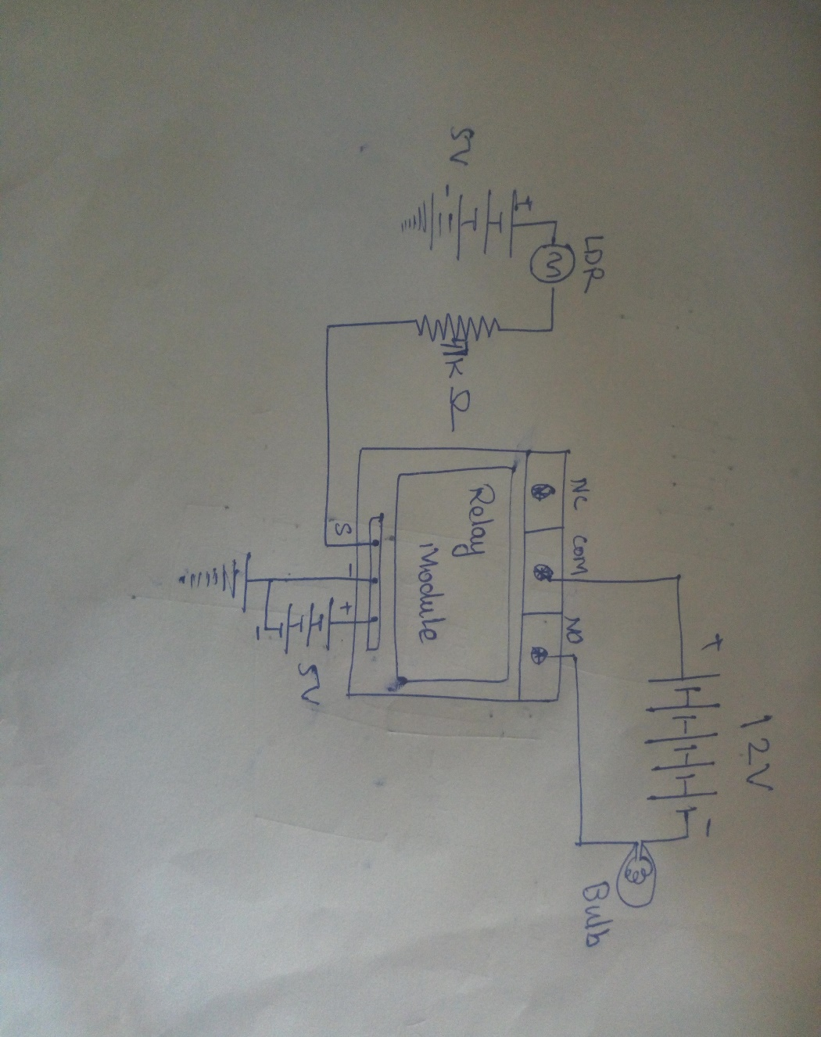

# Steps of Circuit Completion

* The positive terminal of a 5V battery is connected to the LDR and the negative to ground.
* The other end of the LDR is joined to 1k ohm resistor.
* The resistor is then joined to input pin of the relay module.
* Another 5V battery is connected to the VCC of relay module.
* The ground pin is connected to the ground.
* The positive terminal of the 12V battery is connected to the COM pin.
* The negative terminal is attatched to the 12V bulb.
* The other end of the bulb is connected to the NO pin.
* Concerned pics are attatched on the next page.

# Program Code

* No arduino was used in the project thus no program code was required for the project.

GitHub Project Link: https://github.com/duskovercast/beee-file

WEEK 1&2:

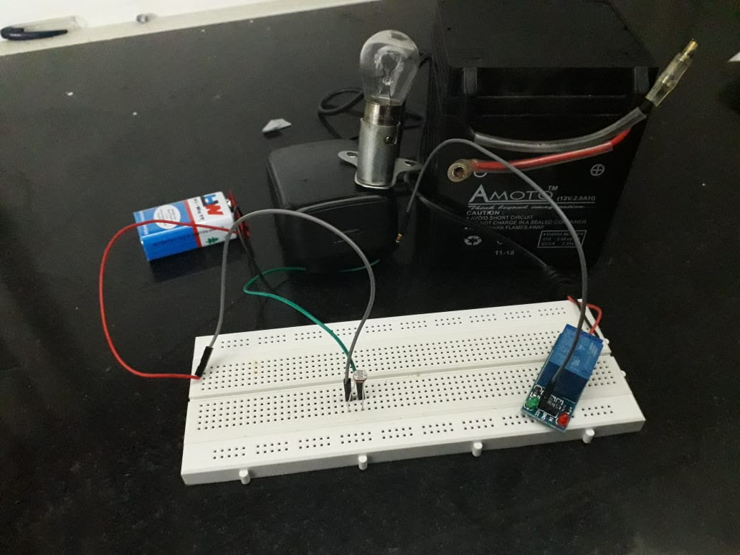

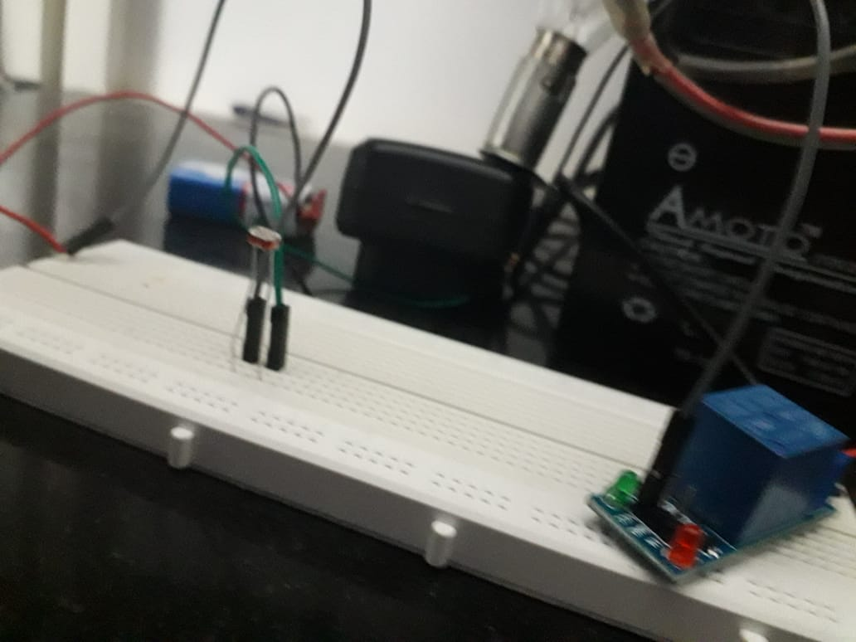

WEEK 2&3:

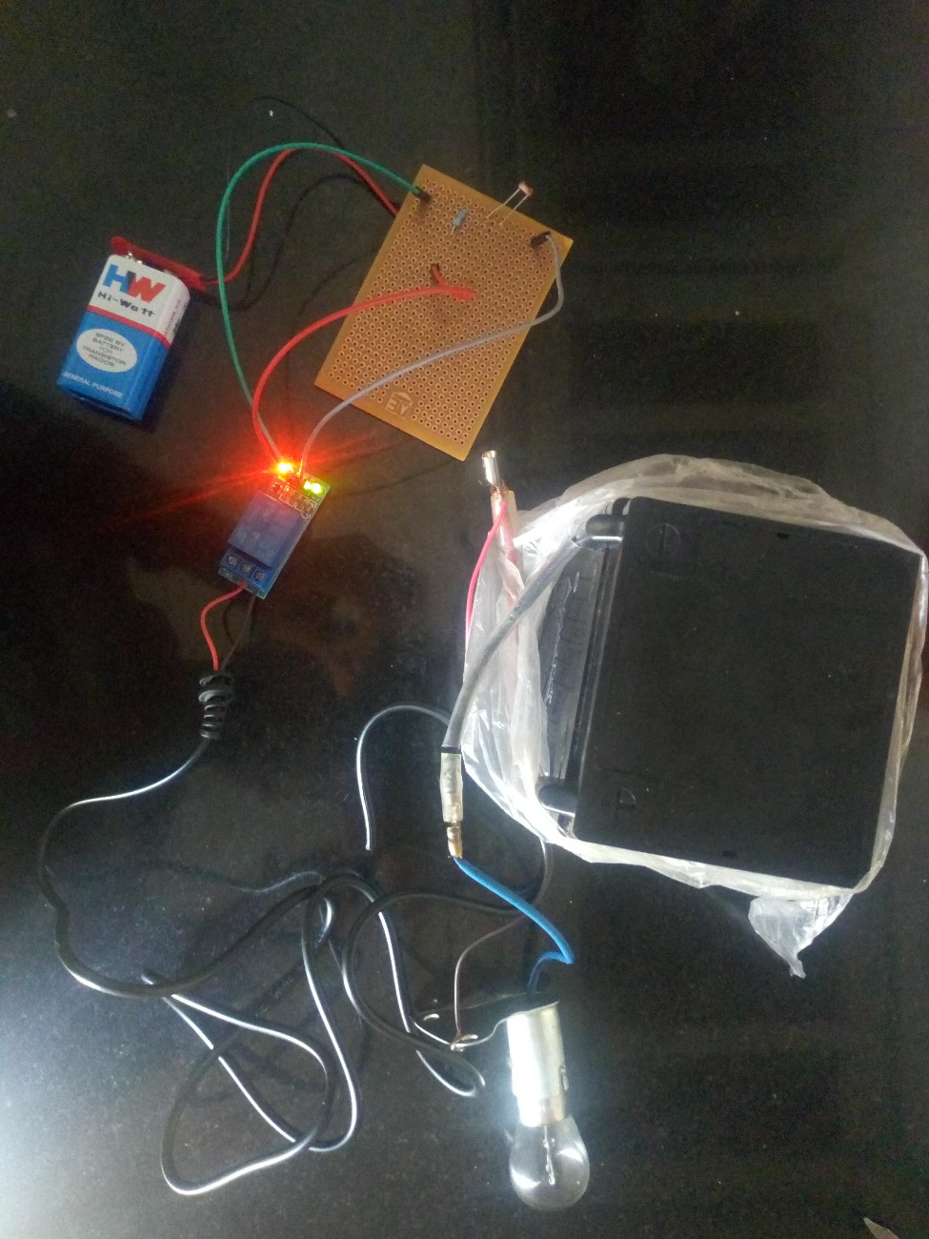

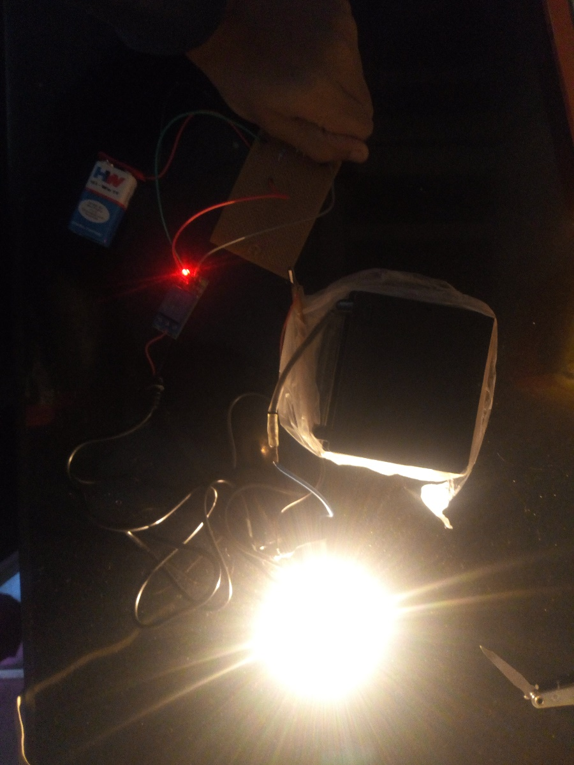

THANKING YOU